# **Name: Abdurrahman Qureshi**

# **Roll No: 242466**

Practical No: 1

1) Implementation of Bikers problem using input of five bikers speed.

CODE:

package EXP2;  
  
import java.util.Scanner;  
  
public class biker {  
 public static void main(String[] args) {  
 Scanner scanner = new Scanner(System.in);  
  
 double[] speeds = new double[5];  
  
 System.out.println("Enter the speeds of 5 racers:");  
 for (int i = 0; i < 5; i++) {  
 System.out.print("Speed of racer " + (i + 1) + ": ");  
 speeds[i] = scanner.nextDouble();  
 }  
  
 double sum = 0;  
 for (double speed : speeds) {  
 sum += speed;  
 }  
 double averageSpeed = sum / speeds.length;  
  
 System.out.println("\nQualifying racers (speed greater than average speed of " + averageSpeed + "):");  
 for (int i = 0; i < speeds.length; i++) {  
 if (speeds[i] > averageSpeed) {  
 System.out.println("Racer " + (i + 1) + " speed: " + speeds[i]);  
 }  
 }  
  
 scanner.close();  
 }  
}

OUTPUT:

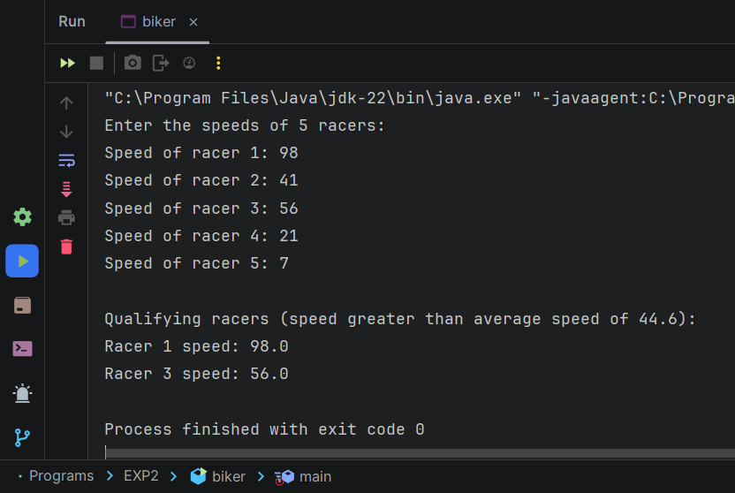

2) Implementation of Salary Problem to calculate total salary based on Basic Salary.

CODE:

package EXP2;  
  
import java.util.Scanner;  
  
class Em {  
 public static void main(String[] args) {  
 float DA, HRA, PF, gr_sal, net_sal;  
 float CCA = 240f, PT = 100f;  
 Scanner a = new Scanner(System.*in*);  
 System.*out*.print("enter employee no: ");  
 int r = a.nextInt();  
 System.*out*.print("enter your basic: ");  
 float f = a.nextFloat();  
 System.*out*.print("enter employee name:");  
 String w = a.next();  
  
 DA = (0.7f) * f;  
 HRA = (0.3f) * f;  
 PF = (0.1f) * f;  
  
 gr_sal = (f + DA + HRA);  
 net_sal = (gr_sal - CCA - PT - PF);  
 System.*out*.println("Name: " + w);  
 System.*out*.println("your Gross Salary : " + gr_sal);  
 System.*out*.println("your Net Salary : " + net_sal);  
 }  
}

OUTPUT:

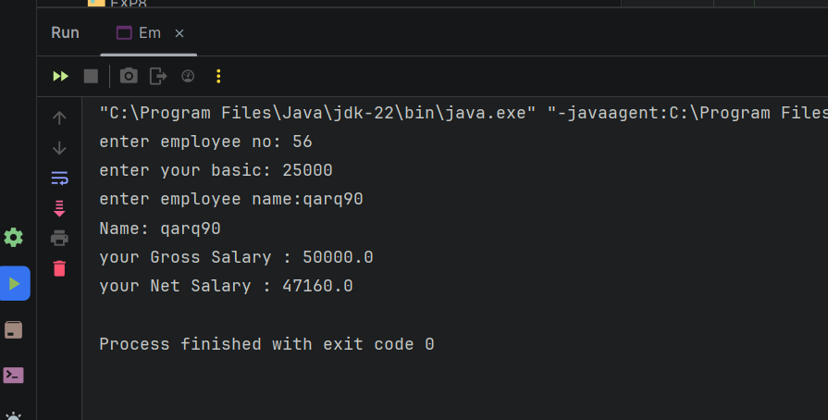

3) Implementation of Menu Driven Bank Example.

CODE:

package EXP2;  
  
import java.util.Scanner;  
  
class bank {  
 private String name;  
 private String accno;  
 private static long *balance* = 0;  
  
 static Scanner *KB* = new Scanner(System.*in*);  
  
 void createAccount() {  
 System.*out*.println("Enter Name: ");  
 name = *KB*.next();  
 System.*out*.println("Enter Account No: ");  
 accno = *KB*.next();  
 System.*out*.println("Enter Balance: ");  
 *balance* = *KB*.nextLong();  
 System.*out*.println("\n");  
 }  
  
 void showAccount() {  
 System.*out*.println("Name: " + name + "\nAccount No: " + accno + "\nBalance: " + *balance* + "\n");  
 }  
  
 void deposit() {  
 long amt;  
 System.*out*.println("Enter Amount you want to deposit: ");  
 amt = *KB*.nextLong();  
 *balance* += amt;  
 }  
  
 void withdraw() {  
 long amt;  
 System.*out*.println("Enter amount you want to withdraw: ");  
 amt = *KB*.nextLong();  
 if (*balance* >= amt) {  
 *balance* -= amt;  
 } else {  
 System.*out*.println("Less balance. Transaction failed.");  
 }  
 }  
  
 boolean search(String acn) {  
 if (accno.equals(acn)) {  
 showAccount();  
 return true;  
 }  
 return false;  
 }  
  
 void computeInterest() {  
 System.*out*.println("Enter term in months to calculate interest on current balance");  
 System.*out*.print("Term (Months): ");  
 int t = *KB*.nextInt();  
 System.*out*.println("Our Bank's ROI is 8%");  
 double interest = *getBalance*() * 0.08 * (t / 12.0);  
 System.*out*.println("Interest after " + t + " months will be: " + interest);  
 System.*out*.println("");  
 }  
  
 static double getBalance() {  
 return *balance*;  
 }  
}  
  
class ExBank {  
 public static void main(String[] args) {  
 Scanner KB = new Scanner(System.*in*);  
 System.*out*.println("How many customers do you want to input? ");  
 int n = KB.nextInt();  
 bank[] C = new bank[n];  
 for (int i = 0; i < C.length; i++) {  
 C[i] = new bank();  
 C[i].createAccount();  
 }  
 int ch;  
 do {  
 System.*out*.println("Main menu\n1. Display All\n2. Search by Account\n3. Deposit\n4. Withdrawal\n5. Compute Interest\n6. Exit ");  
 System.*out*.print("\nEnter your choice: ");  
 ch = KB.nextInt();  
 switch (ch) {  
 case 1:  
 for (bank bank : C) {  
 bank.showAccount();  
 }  
 break;  
 case 2:  
 System.*out*.print("Enter Account No you want to search: ");  
 String acn = KB.next();  
 boolean found = false;  
 for (bank bank : C) {  
 found = bank.search(acn);  
 if (found) {  
 break;  
 }  
 }  
 if (!found) {  
 System.*out*.println("Search Failed. Account does not exist.");  
 }  
 break;  
 case 3:  
 System.*out*.print("Enter Account No: ");  
 acn = KB.next();  
 found = false;  
 for (bank bank : C) {  
 found = bank.search(acn);  
 if (found) {  
 bank.deposit();  
 break;  
 }  
 }  
 if (!found) {  
 System.*out*.println("Search Failed. Account does not exist.");  
 }  
 break;  
 case 4:  
 System.*out*.print("Enter Account No: ");  
 acn = KB.next();  
 found = false;  
 for (bank bank : C) {  
 found = bank.search(acn);  
 if (found) {  
 bank.withdraw();  
 break;  
 }  
 }  
 if (!found) {  
 System.*out*.println("Search Failed. Account does not exist.");  
 }  
 break;  
 case 5:  
 System.*out*.print("Enter Account No: ");  
 acn = KB.next();  
 found = false;  
 for (bank bank : C) {  
 found = bank.search(acn);  
 if (found) {  
 bank.computeInterest();  
 break;  
 }  
 }  
 if (!found) {  
 System.*out*.println("Search Failed. Account does not exist.");  
 }  
 break;  
 case 6:  
 System.*out*.println("Exiting...");  
 break;  
 default:  
 System.*out*.println("Invalid choice.");  
 break;  
 }  
 } while (ch != 6);  
 KB.close();  
 }  
}

OUTPUT:

